Geography Examination

IMPORTANT INFORMATION FOR TEACHERS

This examination is designed to assess student learning from a sample of Geography related Year 10 content from the K-10 Society and Environment Syllabus. This content is drawn from the Place and Space and Natural and Social Systems outcomes. Relevant prior learning for the senior secondary Geography course was also considered in the development of the exam.

The exam is provided as a sample that teachers can modify and adapt as they see fit. It is recognised that a variety of content is studied in Year 10 Society and Environment classrooms across the state. Therefore, teachers using this exam should carefully review it and consider amendments that reflect the specific learning experiences and/or characteristics of their students.

Results from this examination can be used within and between schools for evaluative, comparative and diagnostic purposes. However, it must be recognised that any student achievement information provided by this exam only represents a portion of the total evidence teachers will use in assessing overall student performance in the Society and Environment Learning Area. Similarly, it should only be used as one point of reference for considering the preparedness of students for the senior secondary Geography course.

(SCHOOL NAME)

Department of Society and Environment

Year 10 Exam

GEOGRAPHY

PLACE AND SPACE

NATURAL SYSTEMS

EXAM CONDITIONS

Time allowed for this exam

Reading Time: 5 Minutes
Working time: 60 Minutes

Completion Requirements

This examination is divided into three sections:

Section A: Question 1
COMPULSORY QUESTION. You must answer this question.

This section is worth twelve (12) marks

Section B: Questions 2 and 3

Answer ONE question
This section is worth fourteen (14) marks

Section C: Questions 4 and 5

Answer ONE question
This section is worth fourteen (14) marks

Marks allocated to each task in a question are listed with the task.

TOTAL MARKS FOR THIS EXAMINATION: 40 marks

SECTION A
Question 1 (COMPULSORY QUESTION) (12 Marks)

Closely study the maps for Question 1 before completing the questions/tasks below.

- Identify the three Australian states that experience extreme risk of fire. (3)
i) __________________________________
ii) __________________________________
iii) _________________________________

- STATE two reasons why the Low Risk area on Map 1 is not likely to experience disastrous fires. (2)

_____________________________________________________________________________

_____________________________________________________________________________

_____________________________________________________________________________

_____________________________________________________________________________

- EXPLAIN why winter and spring are the fire seasons for northern Australia, and summer and autumn are the fire seasons for southern Australia. (3)

_____________________________________________________________________________

_____________________________________________________________________________

_____________________________________________________________________________
_____________________________________________________________________________
_____________________________________________________________________________
_____________________________________________________________________________
_____________________________________________________________________________
_____________________________________________________________________________

- State whether you believe that climate has a major, moderate or minimal effect on the location of the fire risk areas in Australia. Provide reasons and examples to justify your response. (4)

_____________________________________________________________________________

_____________________________________________________________________________

_____________________________________________________________________________

_____________________________________________________________________________
_____________________________________________________________________________
_____________________________________________________________________________
_____________________________________________________________________________
_____________________________________________________________________________
_____________________________________________________________________________
_____________________________________________________________________________
_____________________________________________________________________________

End of Section 1

SECTION B
Answer EITHER Question 2 OR Question 3

Question 2 (14 marks)

For a natural disaster you have studied, complete the following questions.

- When and where did the disaster occur? (2)

_____________________________________________________________________________

_____________________________________________________________________________

- DESCRIBE the type and extent of the damage caused by the disaster. (2)

_____________________________________________________________________________

_____________________________________________________________________________

_____________________________________________________________________________

_____________________________________________________________________________

- EXPLAIN the cause(s) of the disaster. (2)

___________________________________________________________________________________________

_____________________________________________________________________________

_____________________________________________________________________________

_____________________________________________________________________________
_____________________________________________________________________________

_____________________________________________________________________________

- What impact did the disaster have on
- The environment in the region where it occurred? (1.5)

_____________________________________________________________________________

_____________________________________________________________________________

_____________________________________________________________________________

___________________________________________________________________________

- The community of people in the region where it occurred? (1.5)

_____________________________________________________________________________

_____________________________________________________________________________

_____________________________________________________________________________

_____________________________________________________________________________

- The nation in which it occurred? (1)

_____________________________________________________________________________

_____________________________________________________________________________

_____________________________________________________________________________

_____________________________________________________________________________

- With respect to the example you have used, what measures are being taken to prevent
the recurrence of the disaster, or to mitigate the effects of any such natural disasters in
the future? (4)

_____________________________________________________________________________

_____________________________________________________________________________

_____________________________________________________________________________

_____________________________________________________________________________

_____________________________________________________________________________

_____________________________________________________________________________

_____________________________________________________________________________

_____________________________________________________________________________
_____________________________________________________________________________

Question 3 (14 Marks)

Study the short extract and the maps of California and the San Andreas Fault to answer the following questions.

- Which major cities are shown as being affected by the San Andreas Fault? (1)

______________________________________________________________________________

- What effect does the movement of the San Andreas Fault have on the cultural and
natural landscape? (2)

_____________________________________________________________________________

_____________________________________________________________________________

_____________________________________________________________________________

_____________________________________________________________________________
_____________________________________________________________________________

_____________________________________________________________________________

- Is there any part of California in which cities could be safely established?
  - Show on Map A the areas in which safe cities could be built. (1)
  - State the reasons for your decision. (2)

_____________________________________________________________________________

_____________________________________________________________________________

_____________________________________________________________________________

_____________________________________________________________________________

- What changes to lifestyle and the built landscape are made by governments and
residents in the affected cities to combat the problems associated with living in an
earthquake zone? (4)

_____________________________________________________________________________

_____________________________________________________________________________
_____________________________________________________________________________

_____________________________________________________________________________

_____________________________________________________________________________

_____________________________________________________________________________

_____________________________________________________________________________

_____________________________________________________________________________
_____________________________________________________________________________
____________________________________________________________________________

- Why do the residents of regions affected by severe natural disasters, such as earthquakes
and volcanic eruptions, continue to live in the region, despite the known dangers? (4)

_____________________________________________________________________________

_____________________________________________________________________________

_____________________________________________________________________________

_____________________________________________________________________________

_____________________________________________________________________________

_____________________________________________________________________________

_____________________________________________________________________________

______________________________________________________________________________

End of Section 2

SECTION C
Answer EITHER Question 4 OR Question 5

Question 4

Study the Diagram provided for Question 4. (14 marks)

- Identify an ecosystem you have studied (e.g. tropical rainforest, desert, sclerophyllous forest).
__________________________________________
Select three of the following components from the diagram (soil, climate, landforms, plants, animals) and briefly DESCRIBE the CHARACTERISTICS of each component for the ecosystem you identified above. (3)
Component 1 : _________________________________
Characteristics:______________________________________________________
_____________________________________________________________________________
Component 2 : _________________________________
Characteristics:______________________________________________________
__________________________________________________________________
Component 3 : _________________________________
Characteristics:______________________________________________________
__________________________________________________________________
- Using examples from the ecosystem you have studied, EXPLAIN how two of the components described in part a) are interdependent. (3)

_____________________________________________________________________________

_____________________________________________________________________________

_____________________________________________________________________________

_____________________________________________________________________________
_____________________________________________________________________________
_____________________________________________________________________________
_____________________________________________________________________________

- Name the threats that exist to the ecosystem you have studied and describe how each threat may
change the ecosystem. (4)

_____________________________________________________________________________

_____________________________________________________________________________

_____________________________________________________________________________

_____________________________________________________________________________
_____________________________________________________________________________
_____________________________________________________________________________
_____________________________________________________________________________
_____________________________________________________________________________
____________________________________________________________________________________________
- What steps can be, or are being, taken by Australia’s governments to mitigate the
threats and sustain the ecosystem? (4)

_____________________________________________________________________________
_____________________________________________________________________________

_____________________________________________________________________________

_____________________________________________________________________________

_____________________________________________________________________________

_____________________________________________________________________________

_____________________________________________________________________________

_____________________________________________________________________________
____________________________________________________________________________

Question 5 (14 marks)

Read the extracts for Question 5 and use the information in them to answer the related questions.

- Match each of the numbered “Environmental Facts – April 2009” from the first extract to its related environmental issue in the table below: (2)
Environmental Issue | Environmental Fact No.
Air Pollution
Global warming
Reduction of biodiversity
Deforestation
Clean energy sources
Ozone depletion

- Some of the “Environmental Facts” are linked, either as “Cause and Consequence” or because they are components of a broader environmental problem.
Identify two sets of linked “Environmental Facts” and briefly explain why they are linked (4)
Linked Pair 1: ___________________________ and ________________________________
Explanation: ________________________________________________________________
____________________________________________________________________________
____________________________________________________________________________
Linked Pair 2: ___________________________ and ________________________________
Explanation: ________________________________________________________________
____________________________________________________________________________
____________________________________________________________________________
- For ONE environmental issue from the Selected Major Environmental Issues, describe the changes occurring in the environment associate with the issue. Include an example to
support your description. (3)
____________________________________________________________________________
____________________________________________________________________________
____________________________________________________________________________
____________________________________________________________________________
____________________________________________________________________________
____________________________________________________________________________
____________________________________________________________________________
____________________________________________________________________________
- For ONE environmental problem from the Selected Major Environmental Issues extract, briefly describe:
  - how Australia is being affected by the problem. (2.5)
________________________________________________________________________
________________________________________________________________________
________________________________________________________________________
________________________________________________________________________
________________________________________________________________________
________________________________________________________________________
  - proposed and/or current actions from the federal, state and/or local governments, or other agencies, to address the problem.
If there are no proposed actions, explain why you think this is the case (2.5)
________________________________________________________________________
________________________________________________________________________
________________________________________________________________________
________________________________________________________________________
________________________________________________________________________
________________________________________________________________________

End of Section 3

End of Examination

MAPS FOR QUESTION 1 (Compulsory Question)

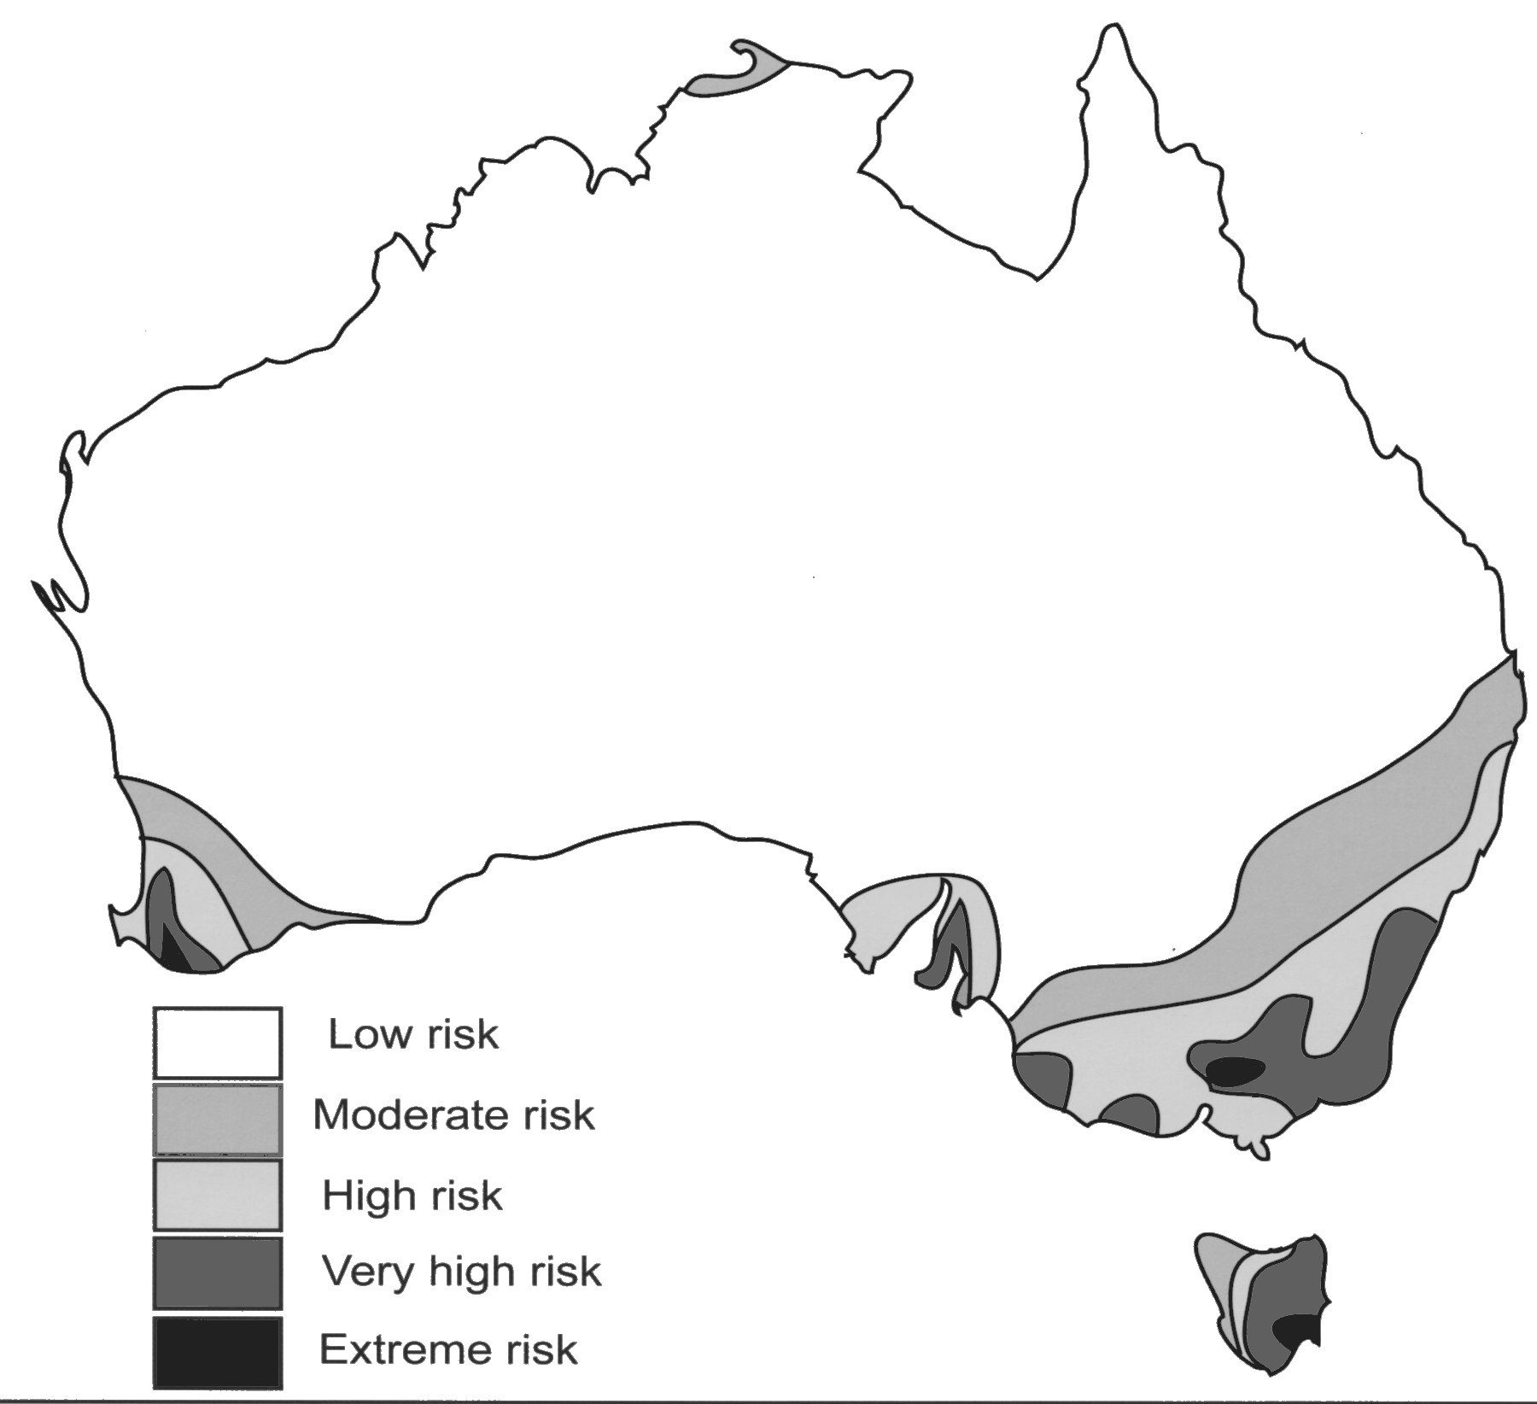

Map 1: Fire Risk Areas In Australia

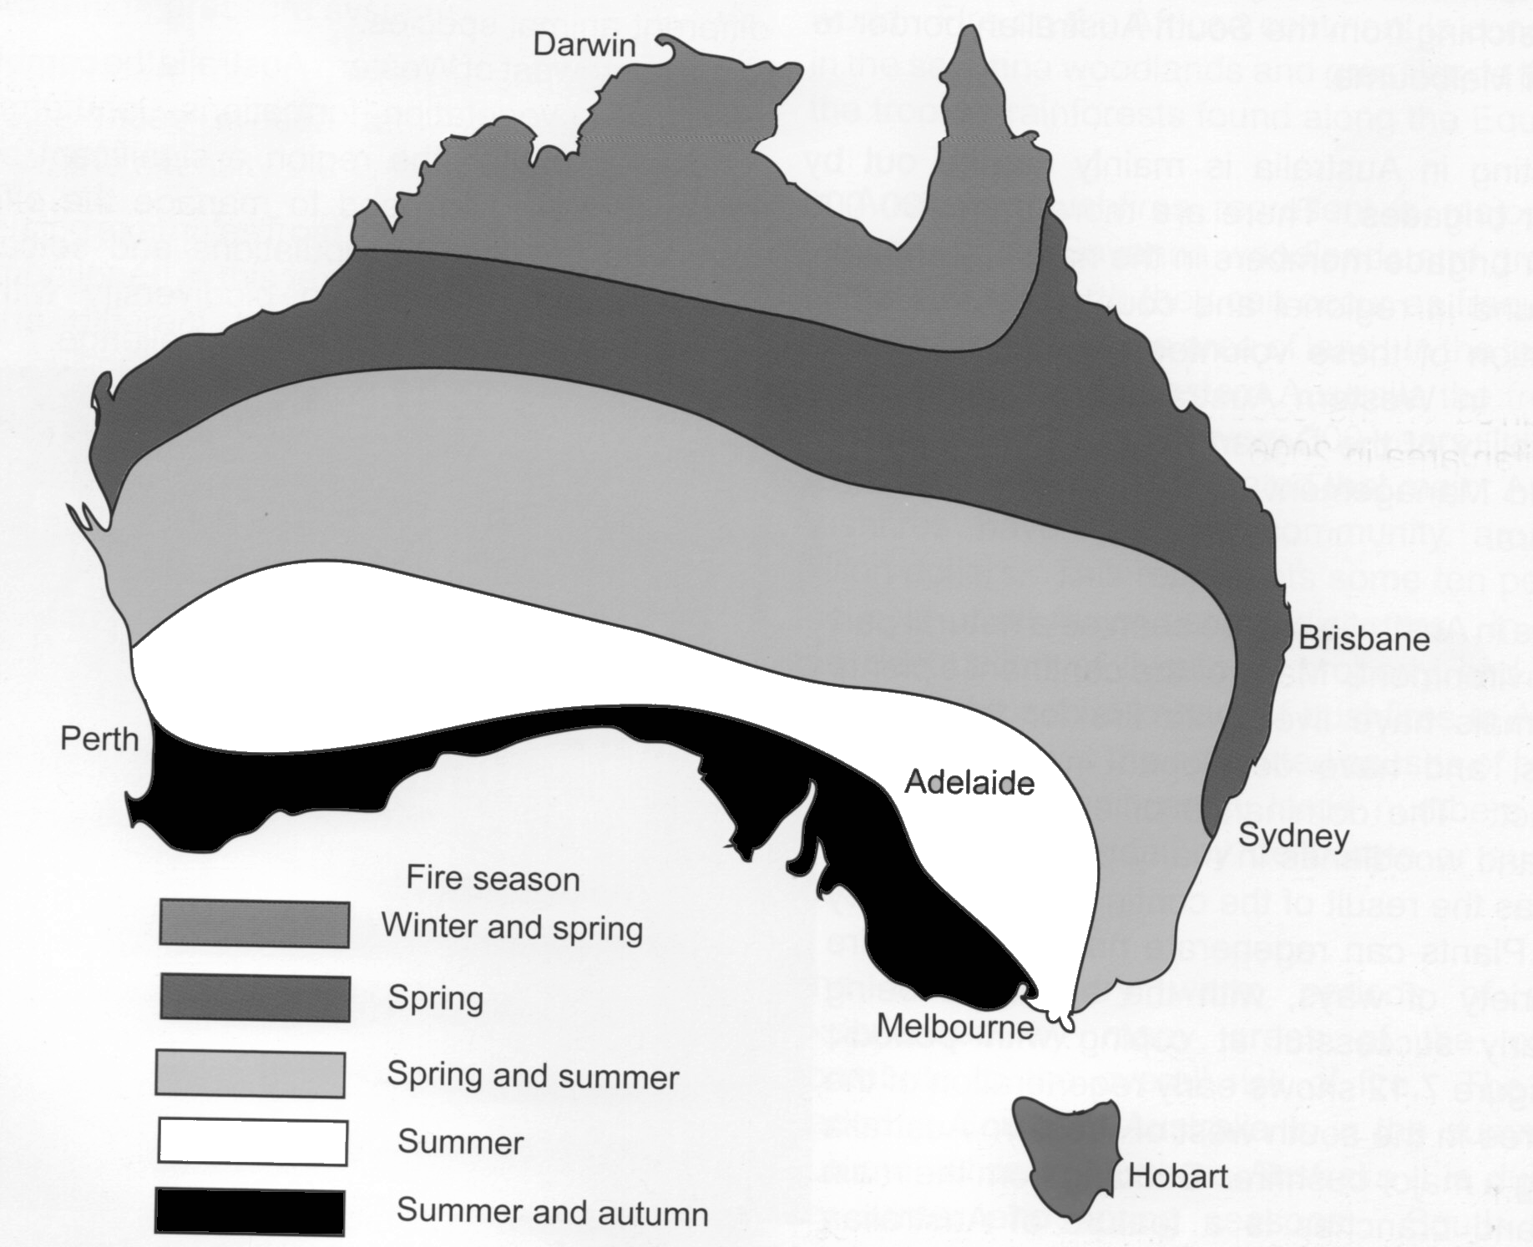

Map 2: Fire Seasons In Australia

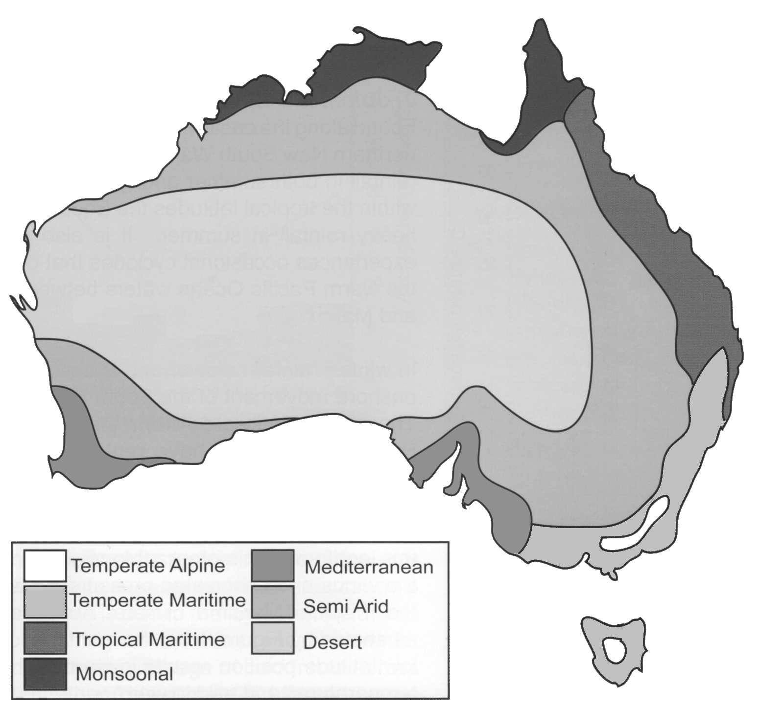

Map 3: Climatic Regions In Australia

All three maps are sourced from: Hazards, Impacts and Responses: Snell et al. Geographical Association of Western Australia (Inc)

EXTRACT AND MAPS FOR QUESTION 3

…From the air the fault can be seen as a linear trough that is marked be a number of distinctive landforms. (such as) Small narrow lakes….straight escarpments, narrow ridges and streams that turn sharply as they cross the fault. The sideways…movement on…the fault has produced breaks in roads, walls, fences and other structures that cross it.

It has been estimated that the movement along the fault has been more than 500km…(in)..20 million years. As the southern section of California continues to creep northwards….Los Angeles will eventually become part of San Fransisco…

Small earthquake tremors are very common in California and indicate energy from the movement along the San Andreas fault is being released on a regular basis…..

Source:

Hazards, Impacts and Responses: Snell et al. Geographical Association of Western Australia (inc) YEAR??? Page 38

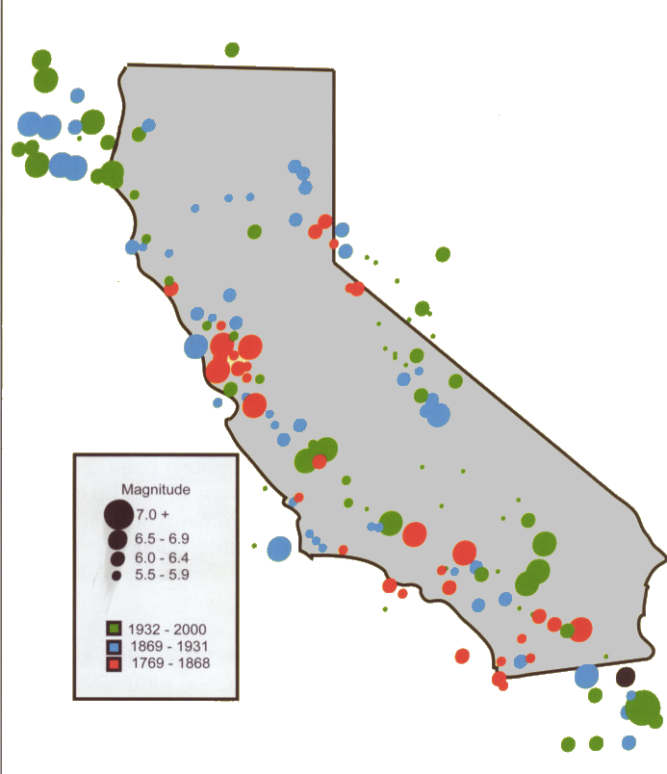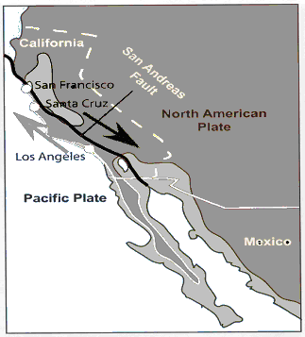

Map A Map B
Magnitude and Distribution of Californian earthquakes Location of San Andreas Fault

Source:
Hazards, Impacts and Responses: Snell et al. Geographical Association of Western Australia (Inc) Page 38 and 39

DIAGRAM FOR QUESTION 4

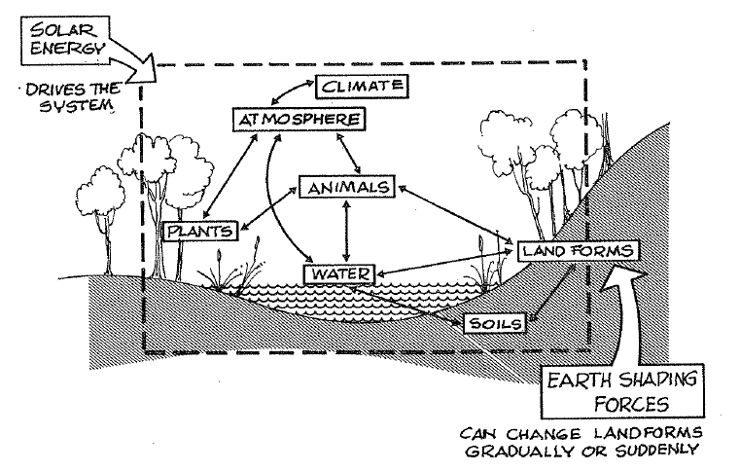

INFORMATION FOR QUESTION 5

Environmental Facts – April 2009

- Over the 10-year period from 1990 to 2000, forests shrank by 940,000 square kilometres due to conversion into farmland and other uses.
- Nearly half the world's population depends on solid fuels, including wood, dung, crop residues and coal, to meet their most basic energy needs. Indoor air pollution from cooking with such fuels is responsible for more than 1.6 million deaths annually, mostly among women and children.
- The use of solar energy and wind power have grown by more than 30 percent annually over the past five years in countries such as Germany, Japan, and Spain thanks to policies that have encouraged their use.
- A concerted global effort to reduce the use of ozone-depleting chlorofluorocarbons (CFCs) led to an 81 percent decline in production during the 1990s, and a marked slowing in the growth of the Antarctic ozone hole.
- Bird extinctions are running at about 50 times the natural rate, due to habitat loss and other consequences of human activity.
- The global rate of ice melt has more than doubled since 1988 and could raise sea levels 27 centimetres by 2100.

SELECTED MAJOR ENVIRONMENTAL ISSUES

Land degradation
Soil degradation affects a third of the world’s land and diminishes its ability to produce food for the growing population. It is caused by deforestation, poor land and water management, over-use of fertilisers and pesticides, poor waste disposal, clearance of poor land for growing food and air pollution.

Urbanisation
Though 60 to 70 per cent of people in developing countries live in rural areas, more and more people are being attracted to the cities. As cities grow, productive farming land is covered in houses and roads and the remaining land has to produce more food to support even more people.
Rapid urban expansion also puts pressure on infrastructure development and the environment.
Well-planned, densely populated settlements can reduce the need for land conversion, provide opportunities for energy savings and make recycling more cost-effective.

Pollution and climate change
Contamination of air, water and soil can have serious effects on the health of people and the world’s ability to grow food. Since the industrial revolution, the concentration of carbon dioxide in the atmosphere has increased significantly, contributing to the greenhouse effect known as ‘global warming’. Increasing temperatures, more frequent droughts and polar ice melts also affect health and food security.

Marine and coastal degradation
Disposal of wastes, particularly sewage, directly into oceans is a major source of pressure on marine and coastal areas. Population growth and increasing urbanisation, industrialisation and tourism is increasing the extent of the coastal degradation.

